# Getting Started with RStudio

In this lesson we are going to explore RStudio. We will practice entering commands for arithmetic functions, assigning values to objects, and be introduced to the concept of vectors.

## Using R as a calculator

1. Begin by opening RStudio on your computer.

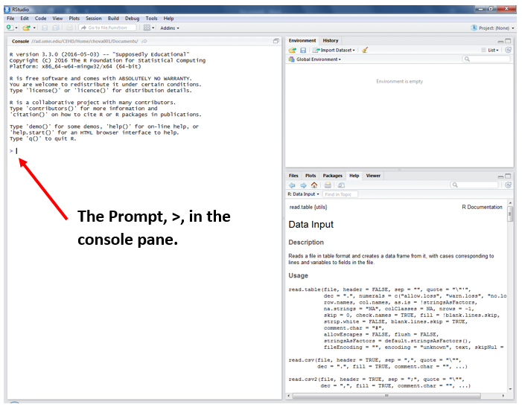

1. To begin, put your cursor at the prompt in the console pane and type, 6+1, and press enter. You should see the following.

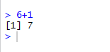

1. R can be used just like a calculator. We can add, subtract, multiple, divide, etc. Try multiplying two values. Type, 2*4, and press enter to get the result 8.
2. Find the square root of 8. Type, sqrt(8), then press enter.

## Assigning Values to Objects

1. To assign a value to an object put your cursor at the prompt in the console pane and type, x <- 6, then press enter. We now have an object called x that contains the value 6. The symbol, <-, is the same as saying is. So x <- 6 is read x is 6.
2. To see what is stored in x, type, print(x), then press enter. When you press enter, R will process the command and print out the result. You should see the following in your console pane.

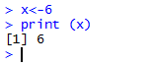

1. To see what is stored in R you can look in the Environment tab in the workspace pane. You should see the object x with a value of 6 in your workspace.

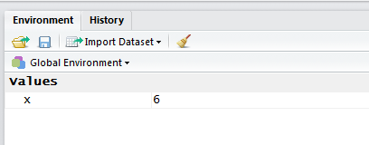

1. We can overwrite x by typing, x <- 11, and pressing enter. Now we have changed the value of x from 6 to 11. You will see the change in the workspace or you can type the command, print (x), to see the value of x.
2. We can also assign characters to objects. Type, e <- “EPSY 1261”, and press enter. We now have a new object e with the characters EPSY 1261.
3. If you put quotation marks around a number R will read the number as a character and not numeric. You will not be able to perform arithmetic function with these numbers. To see this type, xx <- “1” and press enter. See how the object x and xx are different?

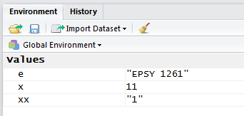

1. Let’s remove the object xx from R’s memory. Type, rm(xx), then press enter. You should no longer see the object xx in the environment tab.
2. Before we move on to arithmetic functions create a new object called y and give it the value 3.
3. If you want you can use the remove command, rm(), and remove e from R’s memory.

## Commands for Arithmetic Functions

1. See saw earlier how to use R as a calculator, we can do the same operations with the objects we assigned previously.
2. Type, x+y, and press enter.

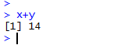

1. Try subtracting, multiplying and dividing x and y.
2. Do your results look like the following?

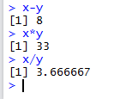

## Creating Vectors

A vector is a sequence of data elements of the same basic type. We will create character, numeric, and logic vectors, assign them to objects, and preform vector arithmetic.

1. To create a vector that contains character strings type, c(“one”, “two”, “three”), then press enter. Assign this vector to the name x1, type, x1<- c(“one”, “two”, “three”), then press enter.
2. To create a vector that contains numbers and assign it to the object x2 type, x2<-c(1,2,3), then press enter.
3. To create a logic vector and assign it to the object x3 type, x3<-c(TRUE, FALSE, TRUE), then press enter.
4. Look in the Environments tab to see your vectors. You should see the following.

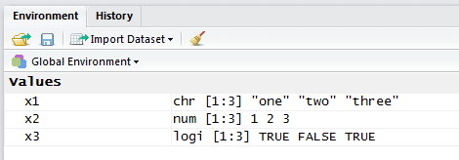

Notice that R recognizes the type of vector based on the components you enter; character strings, numbers or TRUE/FALSE.

1. Let’s remove the three vector we created, x1, x2, x3, using the remove command, rm(). Type, rm(x1, x2, x3), then press enter.
2. Now create two new numeric vectors, x1 and x2, with the following components. X1<-c(0, 2, 4, 6, 8) and x2<-c(1, 3, 5, 7, 9)

We can perform the same arithmetic operations with vectors as we did with individual values.

1. Multiple vector x1 by 5. Did you get the following?



1. Add the two vectors together. We can do this since both x1 and x2 have the same length or each contain five components.



## Assignment

Complete the tasks below in RStudio and then using the snipping tool, , found under the Start button, ., take pictures of your console and workspace panes. Paste these images into a Word document and upload them to the assignment, Getting Started with RStudio, on Moodle. If you are working with a partner each person needs to submit their own assignment.

1. At the prompt type, #, followed by **your** name. ex. #Suzanne Loch
2. Create two objects in R and assign each object a numerical value. You may choose the names and values (consider using your initials and favorite numbers.)
3. Perform the following arithmetic operations on your objects.
   1. Adding
   2. Subtracting
   3. Multiplying
   4. Dividing
   5. Taking the square root of a value, sqrt()
   6. Square one of the values, ex. X^2
   7. Take the natural log of one of the values, log()
   8. Find the absolute value of one of the values, abs()